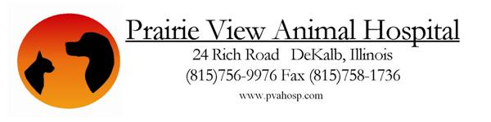

Request for Release of Medical Records:

From:
To:

I request that copies or summaries, as required by state law, of the medical records pertaining to my animal(s) named:

be released to Prairie View Animal Hospital via email at pvah@frontier.com, or by fax at 815-758-1736. I hereby authorize and provide my written consent to this transfer of medical information.

_____________________________________________________ ____________
Signature of Owner or Authorized Agent Date

